Advanced Organic Chemistry
Student’s Name
Institution Affiliation

A
i) 1-phenyl-3-butanone.
ii) 3-methylhexane.
iii) 1-phenyl-1-hexen-3-one. Or 1-phenylhex-1-en-3-one
B.
i) 1-phenyl-2-methylpropanal
ii) Methoxy-2-ethylpentane.
C
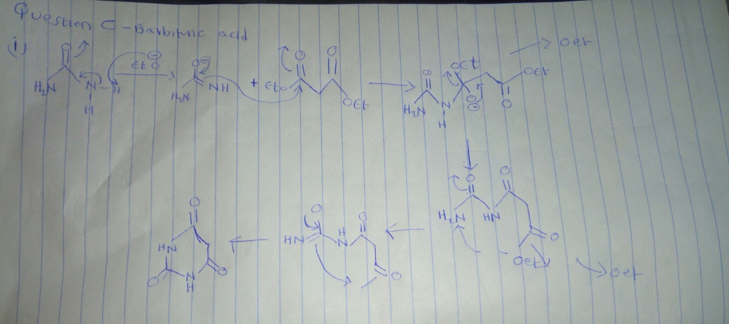
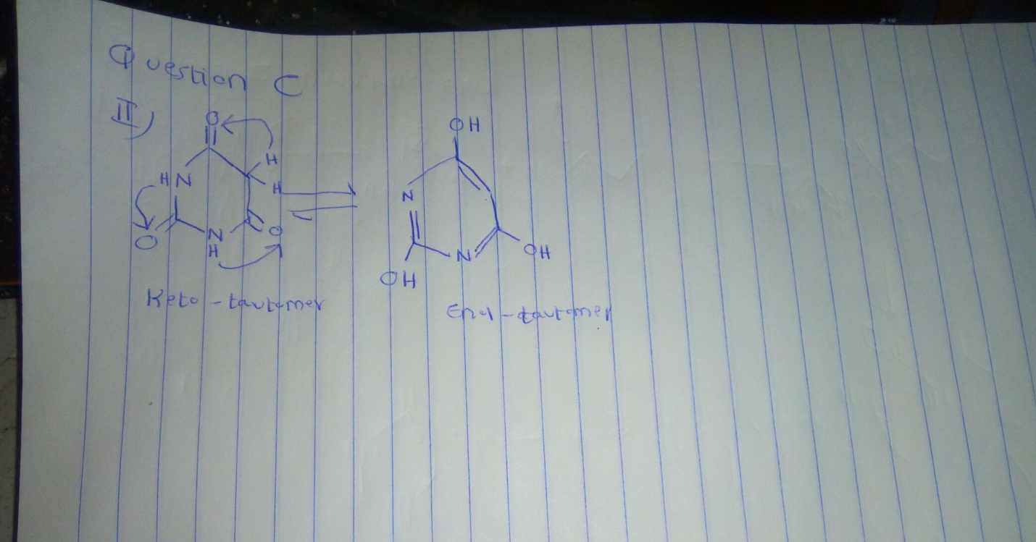
D
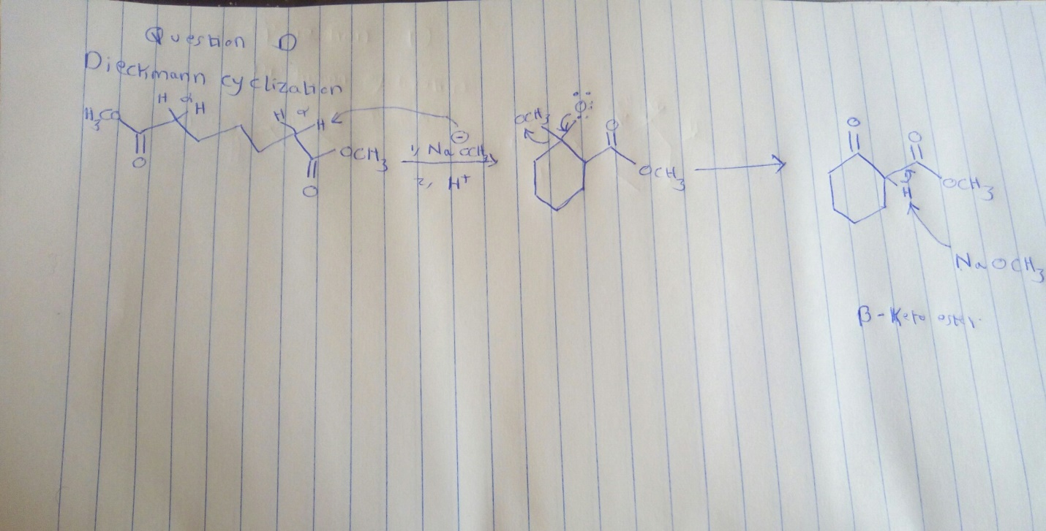
E
